CHAPTER 8 ELECTRICAL

  - PARTS INSPECTION AND SERVICE

  - BATTERY

  - IGNITION SYSTEM

  - CHARGING SYSTEM

  - ELECTRICS STARTING SYSTEM

  - COOLING SYSTEM

  - LIGHTING SYSTEM

  - REVERSE LIMIT SYSTEM

  - GEAR POSITION INDICATOR SWITCH TEST

  - SPEEDOMETER SYSTEM

  - MAIN SWITCH AND HANDLE SWITCH

  - FUEL GAUGE/ FUEL LEVEL SENSOR

  - THE OPERATION PRINCIPLE OF THE ELECTRIC 4WD SHIFT

  - WIRING DIAGRAM

8.1 PARTS INSPECTION AND SERVICE

HEADLIGHT LAMP REPLACEMENT
A. ‘O5 model
- Remove the cover 1 from the ATV.
- Remove the bulb socket with the wire harness from the backside of the lens unit by turn the socket CCW.
- Remove the bulb from the bulb socket carefully.
- Replace the bulb with a new one
(12V 35W/35W), Align the tab with the groove, locating it properly and securely.
- Reinstall the bulb socket, Align the tab with the groove, locating it properly and securely.
- Reinstall the cover.
- Adjust the aim.

B. Headlight on handlebar
1. Remove the front cover of the handlebar from the ATV.
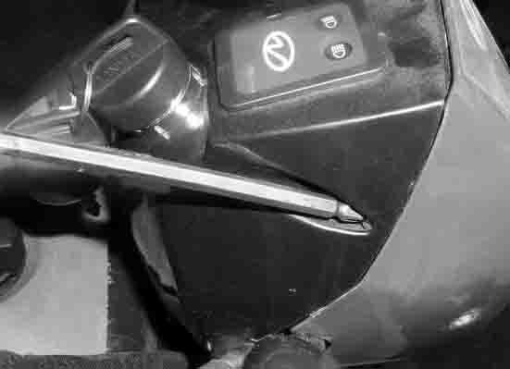
2. Remove the bulb socket with the wire harness from the backside of the lens unit by turn the socket CCW.
- Remove the bulb from the bulb socket carefully.
- Replace the bulb with a new one
(12V 35W/35W), Align the tab with the groove, locating it properly and securely.
- Reinstall the bulb socket, Align the tab with the groove, locating it properly and securely.
- Reinstall the cover.
- Adjust the aim.

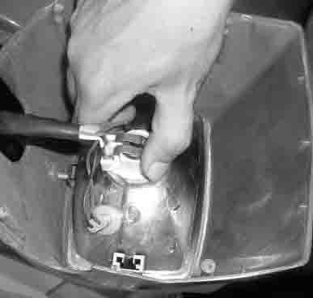

C. ’04 and early model
- Remove lens unit from the headlight.
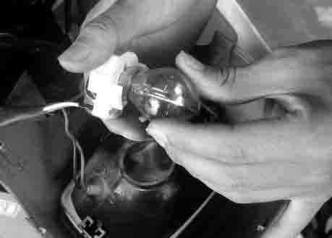
2. Remove the bulb socket with the wire harness from the backside of the lens unit by turn the socket CCW.
- Remove the bulb from the bulb socket carefully.
- Replace the bulb with a new one
(12V 35W/35W), Align the tab with the groove, locating it properly and securely.
- Reinstall the bulb socket, Align the tab with the groove, locating it properly and securely.
- Reinstall the cover.
- Adjust the aim.

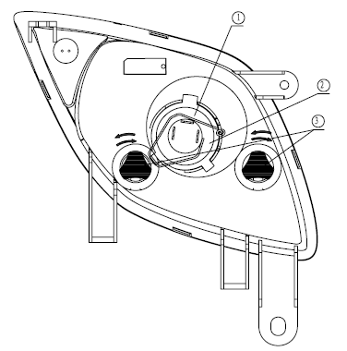
D. Special Edition – Anniversary and B-Type /400ATV-2
- Use bulb 12V 35W/35W.
- Pull the cable plug off the conducting
strip in the socket, remove the clip① before
dismounting the bulb.
- Fit a new bulb into the socket, sitting
properly in the three slots, install the
clip as shown in the fig. and connect
the cable plug to the conducting strip.
4. Change the bulb.
E. ATV400-2B
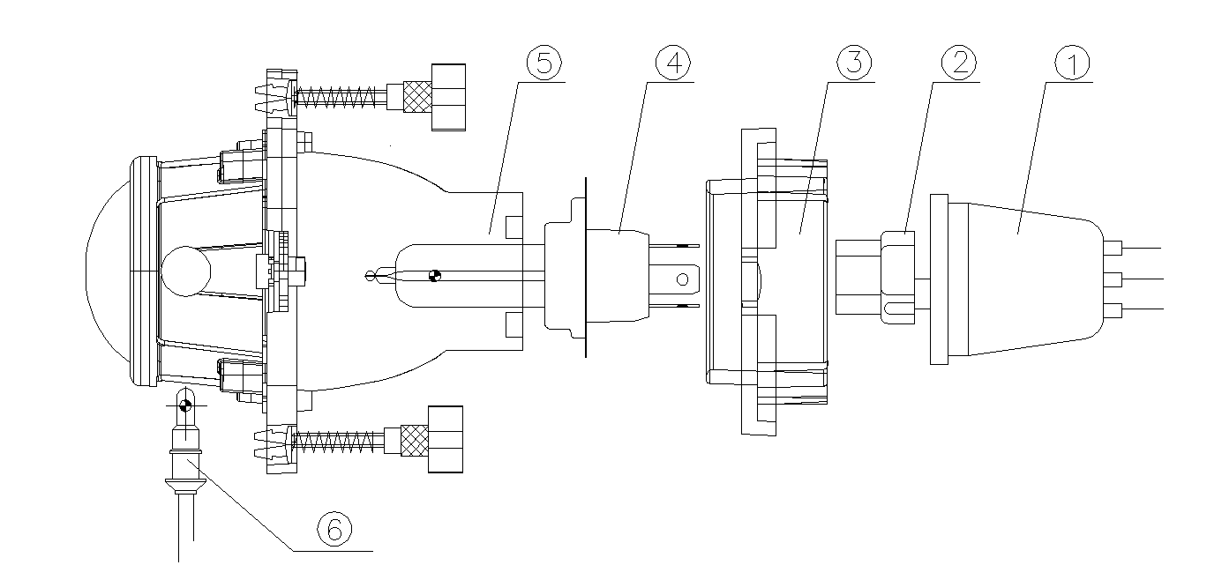
- Use bulb 12V 35W/35W.
- Pull the cable plug off the conducting
strip in the socket, remove the clip① before
dismounting the bulb.
- Fit a new bulb into the socket, sitting
properly in the three slots, install the
clip as shown in the fig. and connect
the cable plug to the conducting strip.
4. Change the bulb.

Headlight Adjustment
- The headlight beam can be adjusted vertically (all models) and horizontally (except the light on handlebar).
- Place the vehicle on a level surface with the headlight approximately 25’(7.6m) from a wall.
- Measure the distance from the floor to the center of the headlight and make a mark on the wall at the same height.
- Start the engine and turn the headlight switch to high beam.
- Observe headlight aim. The most intense part of the headlight beam should be aimed 2’ (51mm) below the mark placed on the wall in step 2. NOTE : Riding weight must be included on the seat.
- Loosen but not remove pivot bolt/ screw and adjust beam to desired position.
- Tighten nut and bolt / screw.
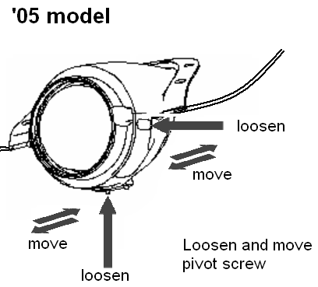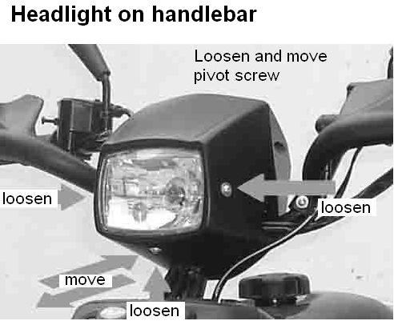

Special Edition – Anniversary and B-Type
and 400ATV-2

To turn the two adjusting screws ③ clockwise is to lower the beam. To turn the two adjusting screws ③ counterclockwise is to heighten the beam.

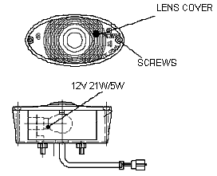
TAILLIGHT / BRAKELIGHT LAMP REPLACEMENT
- From the rear of the taillight remove two screws holding lens cover in place and remove
lens cover.
- Remove lamp and replace it with recommended
lamp.
- Reinstall the lens cover removed in step 1.
- Test the taillight / brake light.

INDICATOR LAMP REPLACEMENT
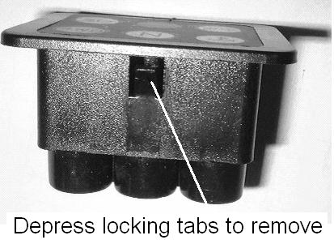
1. Disconnect light from harness, depress locking tabs and remove from pod.
2. Install new light and reassemble pod

8.2 BATTERY

Battery electrolyte is poisonous. It contains sulfuric acid. Serious burns can result from contact with skin, eyes or clothing Antidote:
External: Flush with water.

lnternal: Drink large quantities of water or milk. Follow with milk of magnesia, beaten egg, or vegetable oil. Call physician immediately.

Eyes: Flush with water for 15 minutes and get prompt medical attention.

Batteries produce explosive gases. Keep sparks, flame, cigarettes, etc. away. Ventilate when charging or using in an enclosed space. Always shield eyes when working near batteries.
KEER OUT OF REACH OF CHILDREN

WARNING: The gases given off by a battery are explosive. Any spark or open flame near a battery can cause an explosion which will spray battery acid on anyone close to it. If battery acid gets on anyone, wash the affected area with large quantities of cool water and seek immediate medical attention.

To ensure maximum service life and performance from a new battery, perform the following steps. NOTE: Do not service the battery unless it will be put into regular service within 30 days. After initial service, add only distilled water to the battery. Never add electrolyte after a battery has been in service.
NOTE: New Battery must be fully charged before use.
- Remove vent plug from vent fitting.
- Fill battery with electrolyte to upper level marks on case.
- Set battery aside and allow it to cool and stabilize for 30 minutes.
- Add electrolyte to bring level back to upper level mark on case.
NOTE: This is the last time that electrolyte should be added. If the level becomes low after this point, add only distilled water.
- Charge battery at 1 /10 of its amp /hour rating. Examples: 1 /10 of 14 amp battery = 1.4 amp; 1/10 of 7 amp battery = 0.7 amp (recommended charging rates).
- Check specific gravity of each cell with a hydrometer to assure each has a reading of 1.270 or higher.

BATTERY INSPECTION / REMOVAL
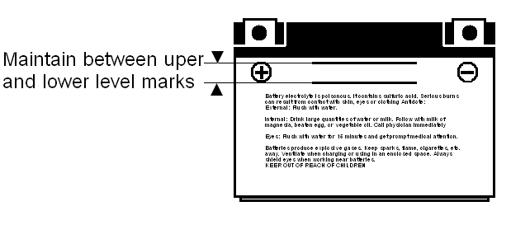
The battery is located under the left rear fender. Inspect the battery fluid level. When the battery fluid nears the lower level, the battery should be removed and distilled water should be added to the upper level line. To remove the battery:
- Disconnect holder strap and remove cover.
- Disconnect battery negative (-) (black) cable first,
followed by the positive (+) (red) cable.

CAUTION
Whenever removing or reinstalling the battery, disconnect the negative (black) cable first and reinstall the negative cable last!
- Disconnect the vent hose.
- Remove the battery.
5. Remove the filler caps and add distilled water only as needed to bring each cell to the proper level.
Do not overfill the battery.
To refill use only distilled water. Tap water contains minerals which are harmful to a battery.
Do not allow cleaning solution or tap water to enter the battery. It will shorten the life of the battery.
- Reinstall the battery caps.

BATTERY INSTALLATION
- Clean battery cables and terminals with a stiff wire brush. Corrosion can be removed using a solution of one cup water and one tablespoon baking soda. Rinse with clean water and dry thoroughly.
- Reinstall battery, attaching positive (+) (red) cable first and then the negative (- ) (black) cable.
- Install clear battery vent tube from vehicle to battery vent.
WARNING: Vent tube must be free from obstructions and kinks and securely installed. If not, battery gases could accumulate and cause an explosion. Vent should be routed away from frame and body to prevent contact with electrolyte. Avoid frame, corrosion will occur.
- Route cables so they are tucked away in front and behind battery.
- Reinstall battery cover and holder strap.
Do not start the engine with the battery disconnected. Vehicle lamps will burn out if battery is disconnected during vehicle operation. Also, the reverse speed limiter can be damaged.

BATTERY TESTING
Whenever a service complaint is related to either the starting or charging systems, the battery should be checked first.
Following are three tests which can easily be made on a battery to determine its condition: OCV Test, Specific Gravity Test and Load Test.

MF (Maintenance Free) battery does not require the Specific Gravity Test and Refill

Open Circuit Voltage Test
Battery voltage should be checked with a digital multitester. Readings of 12.6 or less require further battery testing and charging.
NOTE: Lead acid batteries should be kept at or near a full charge as possible.

Load test
CAUTION: Remove spark plug high tension leads and connect securely to engine ground before proceeding.
NOTE: This test can only be performed on machines with electric starters. This test cannot be performed with an engine or starting system that is not working properly.
A battery may indicate a full charge condition in the OCV test and the specific gravity test, but still may not have the storage capacity necessary to properly function in the electrical system. For this reason, a battery capacity or load test should be conducted whenever poor battery performance is encountered. To perform this test, hook a multitester to the battery in the same manner as was done in the OCV test. The reading should be 12.6 volts or greater. Engage the electric starter and view the registered battery voltage while cranking the engine. Continue the test for 15 seconds. During this cranking period, the observed voltage should not drop below 9.5 volts. If the beginning voltage is 12.6 or higher and the cranking voltage drops below 9.5 volts during the test, replace the battery.

8.3 IGNITION SYSTEM

IGNITION SYSTEM TROUBLESHOOTING
No Spark, Weak or Intermittent Spark
● Spark plug gap incorrect
● Fouled spark plug
● Faulty spark plug cap or poor connection to high tension lead
● Related wiring loose, disconnected, shorted, or corroded
Engine stop switch or ignition switch faulty
● Terminal board or connections wet, corroded
● Poor ignition coil ground (e.g. coil mount loose or corroded)
● Faulty stator (measure resistance of all ignition related windings)
Incorrect wiring (inspect color coding in connectors etc. )
● Faulty ignition coil winding (measure resistance of primary and secondary)
● Worn magneto (RH) end crankshaft bearings
● Sheared flywheel key
● Flywheel loose or damaged
● Trigger coil air gap too wide (where applicable) should be 0.030-0 .050" (0. 75-1.25 mm)
● Excessive crankshaft run out on magneto (RH) end should not exceed 0.005" (0.13mm)
● Faulty CDI module

CIRCUIT DIAGRAM
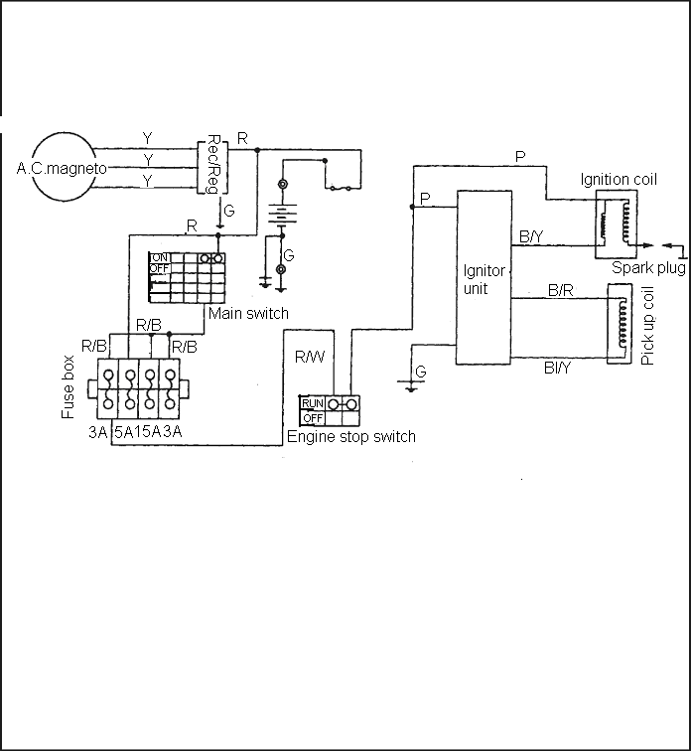

IF THE IGNITION SYSTEM FAILS TO OPERATE

Procedure
Check:
1. Fuse (Main) 7.Pickup coil resistance
2. Battery 8.Main switch
3. Spark plug 9.Engine stop switch
4. lgnition spark gap 10.Wiring connection
5. Spark plug cap resistance (entire ignition system)
6. Ignition coil

1.Fuse |  | NO CONTINUITY
Check switches |  | Replace the fuse.
CONTINUITY
2. Battery |  | INCORRECT
● Check the battery condition.  Refer to "BATTERY INSPECTION" |  | ● Clean battery terminals.   Recharge or replace the battery.
CORRECT |  | Standard spark plug: DR8EA / NGK
3.Spark plug |  | OUT OF SPECIFICATION
● Check the spark plug condition.   Check the spark plug type.   Check the spark plug gap. |  | OUT OF SPECIFICATION
 |  | Repair or replace the spark plug

Spark plug gap: 0.6～0.7mm
*

* |  |  |  | 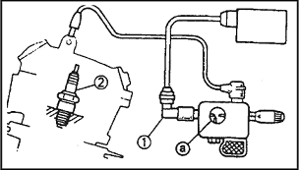
4.lgnition spark gap
● Disconnect the spark plug cap from the spark plug
Connect the ignition tester 1 as shown. 2 Spark plug
Turn the main switch to "ON".
Check the ignition spark gap .
Check the spark by pushing the starter switch, and increase the spark gap until a misfire occurs.
 |  |  |  | MEETS SPECIFICATION
 |  |  |  | The ignition system is not faulty.
Minimum spark gap:  6mm (0.24 in) |  |  |  | The ignition system is not faulty.
OUT OF
SPECIFICATION OR
NO SPARK
Tester (+) lead →
Spark plug side①
Tester (—) lead→
High tension cord side ②
5.Spark plug cap resistance
Remover the spark plug cap.  Connect the pocket tester (ΩX1 k) to the spark plug cap.  NOTE:   When removing the spark plug cap. do not pull the spark plug cap from high tension cord.  Remove→Turning counterclockwise  Connect→Turning clockwise.  Check the high tension cord when connecting the spark plug cap.   When connecting the spark plug cap, cut the high tension cord about 5mm. |  |  |  | 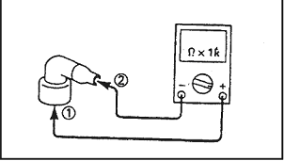
 |  |  |  | OUT OF SPECIFICATION
Spark plug cap resistance:  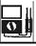  5KΩ(20 ℃) |  |  |  | OUT OF SPECIFICATION
 |  |  |  | Replace the spark plug cap
 |  | CORRECT
*

* |  |  | Tester (+) lead  Pink Terminal  Tester ( ) lead B/Y  Terminal  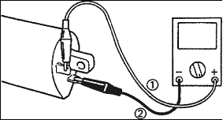

6. Ignition coil resistance
Disconnect the ignition coil connector from the wire harness.
Connect the pocket tester (1) to the ignition coil.
● Check if the primary coil has the specified resistance.
Primary coil resistance: 3.6-4.8Ω(20 ℃)
Tester (+) lead
Spark plug lead
Tester (— ) lead
Pink Terminal

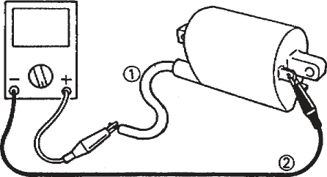
Connect the pocket tester (Ω×1k ) to the ignition coil.
Check the secondary has the specified resistance
Secondary coil resistance:  10.7-14.5 KΩ (20℃) |  |  | OUT OF SPECIFICATION
 | BOTH MEET  SPECIFICATION |  | OUT OF SPECIFICATION
* |  |  | Replace the ignition coil.

* |  |  |  | 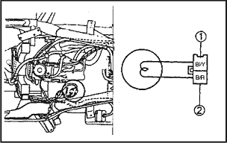
7. Pickup coil resistance
● Disconnect the pickup coil coupler from the wire harness.
Connect the pocket tester (Ω 100) to the pickup coil coupler.

Tester (+) lead →
BI/Y Terminal ①
Tester (- ) lead→
B/R Terminal ②
 |  |  |  | OUT OF SPECIFICATION
● Check the pickup coil has the specified resistance. |  |  |  | OUT OF SPECIFICATION
Primary coil resistance:  168 -252Ω (20℃) |  |  |  | Replace the pickup coil.
 |  |  |  | NO CONTINUITY
 | MEETS  SPECIFICATION |  |  | NO CONTINUITY
8.Main switch |  |  |  | NO CONTINUITY
CHECK SWITCHES |  |  |  | NO CONTINUITY
 |  |  |  | Replace the main switch
 |  | CONTINIUTY |  | NO CONTINUITY
9.Engine stop switch ( for USA model) |  |  |  | NO CONTINUITY
 |  |  |  | Replace the handlebar switch.
 |  | CONTINIUTY |  | Replace the handlebar switch.
 |  | CONTINIUTY |  | POOR CONNECTIONS
10.Wiring connection |  |  |  | POOR CONNECTIONS
Check the connection of the entire ignition system  Refer to “CIRCUIT DIAGRAM”. |  |  |  | POOR CONNECTIONS
 |  |  |  | Correct
 |  | CORRECT |  | Correct
Replace the igniter unit.

8.4 CHARGING SYSTEM
CHARGING SYSTEM CIRCUIT DIAGRAM

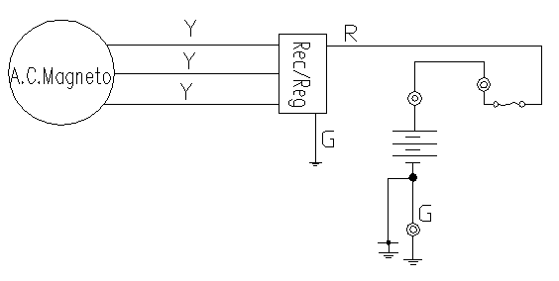

CURRENT DRAW - KEY OFF

CAUTION: Do not connect or disconnect the battery cable or ammeter with the engine running. Damage will occur to light bulbs and speed limiter.
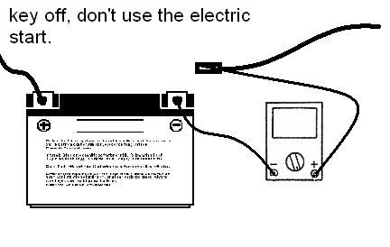
Connect an ammeter in series with the negative battery cable. Check for current draw with the key off, if the draw is excessive, loads should be disconnected from the system one by one until the draw is eliminated. Check component wiring as well as the component for partial shorts to ground to eliminate the draw.

Current draw key off:
Maximum of 0.01DCA(10mA)

CHARGING SYSTEM
Procedure Check:
1. Fuse (Main) 4.Stator coil resistance
2. Battery 5.Wiring system (entire charging system) 3.Charging voltage

- fuse |  | NO CONTINUITY  Replace the fuse
- Battery  Check the battery condition.  Refer to "BATTERY INSPECTION" |  | INCORRECT  Clean battery terminals  Recharge or replace the battery
3.Charging voltage  Connect the engine tachometer to the spark plug lead.  Connect the pocket tester (DC20V) to the battery  Test (+) lead→  Battery (+) terminal ①  Tester (-) lead→  Battery (-) terminal ②  Measure the battery terminal voltage.  start the engine and accelerate to about 5,000rpm  check the terminal voltage  Measured voltage-terminal  Voltage:  0.2-2.5V up  NOTE: Use a fully changed battery. |  | MEETS SPECITICATION  The charging circuit is not faulty  Replace the battery
OUT OF SPECICATION

4. Starter coil resistance  Remove the A.C. magneto coupler from wire harness  Connect the pocket tester (ΩX1) to the stator coil  Tester (+) lead –yellow terminal  Tester (-) lead –yellow terminal  Measure the stator coil resistance  Stator coil resistance 0.5-0.8Ω（20℃） |  | OUT OF SPECITICATION  Replace the stator coil
MEETS SPECIFICATION
5.Wiring connection  check the entire charging system for connections  Refer to “CIRCUIT DIAGRAM” |  | POOR CONNECTION  correct
CORRECT

Replace the rectifier/regulator

8.5 ELECTRICS STARTING SYSTEM
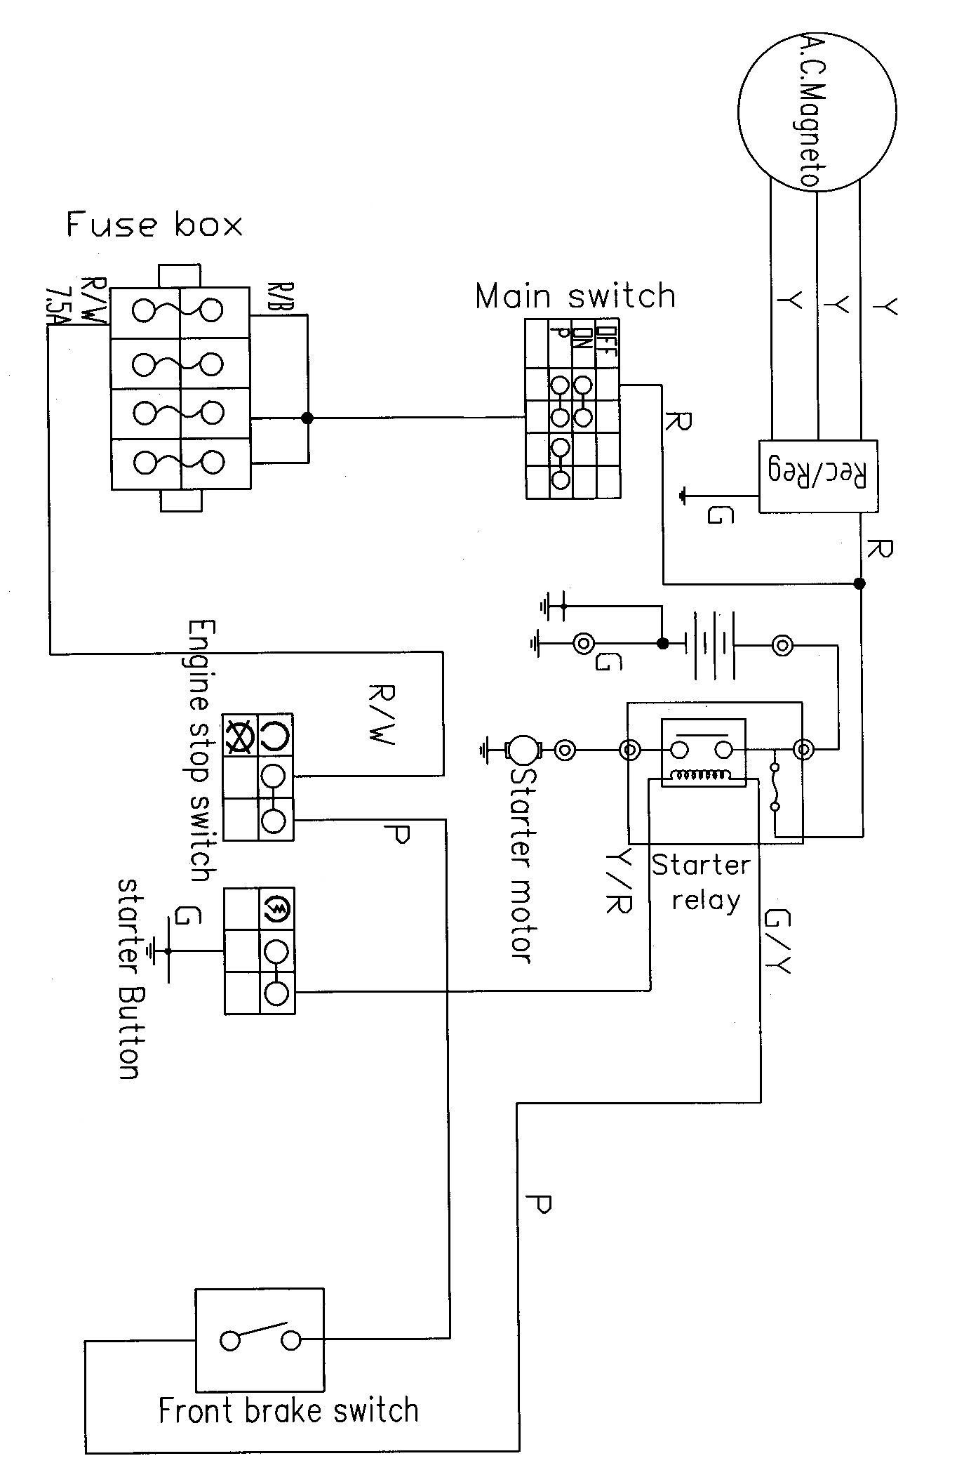
DIAGRAM

TROUBLESHOOTING
IF THE STARTER MOTOR FAILS TO OPERATE

Procedure  Check:  - Fuse (Main)  - Battery  - starter motor  - starter relay  - starting circuit cut-off relay  - main switch | - Engine stop switch  - front/rear brake switch  - starter switch  - wiring connection (entire starting system)
- fuse  refer to “CHECKING SWITCHES” section |  | NO CONTINUITY  Replace the fuse
2. Battery  Check the battery condition.  Refer to "BATTERY INSPECTION" section in CHAPTER 3 |  | INCORRECT  Clean battery terminals  Recharge or replace the battery
- Starter motor  Connect the battery positive terminal and starter motor cable using a jumper lead.  Check the starter motor operation |  | DOES NOT MOVE  Repair or replace the starter motor

4.Starter relay  Disconnect the relay unit coupler from the wire harness.  Connect the pocket tester (Ωx1) and battery (12V) to the relay unit coupler terminals.  Battery (+) lead→  Green/Yellow terminal ①  Battery (-) lead→  Yellow/Red terminal ②  Check the starter relay for continuity.  Test (+) lead → ③ terminal  Test (-) lead → ④ terminal |  | WARNING  A wire used as a jumper lead must have the equivalent capacity as that of the battery lead or more, otherwise it may burn.  This check is likely to produce sparks, so be sure that no flammable gas or fluid is in the vicinity  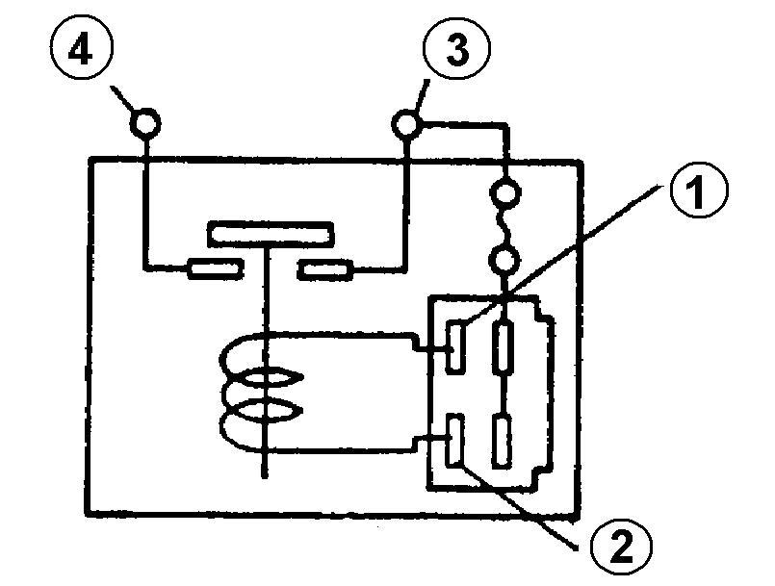
CONTINUITY |  | Replace the starter replay
5. .Starting circuit cut-off relay  Disconnect the starting circuit cut-off relay coupler from the wireharness.  Connect the pocket tester (Ωx1) and battery (12V) to the starting circuit cut-off relay coupler terminals.  Battery (+) lead→ terminal ②  Battery (-) lead→ terminal ④  Check the starting circuit cut-off relay for continuity.  Test (+) lead → ① terminal  Test (-) lead → ③ terminal | 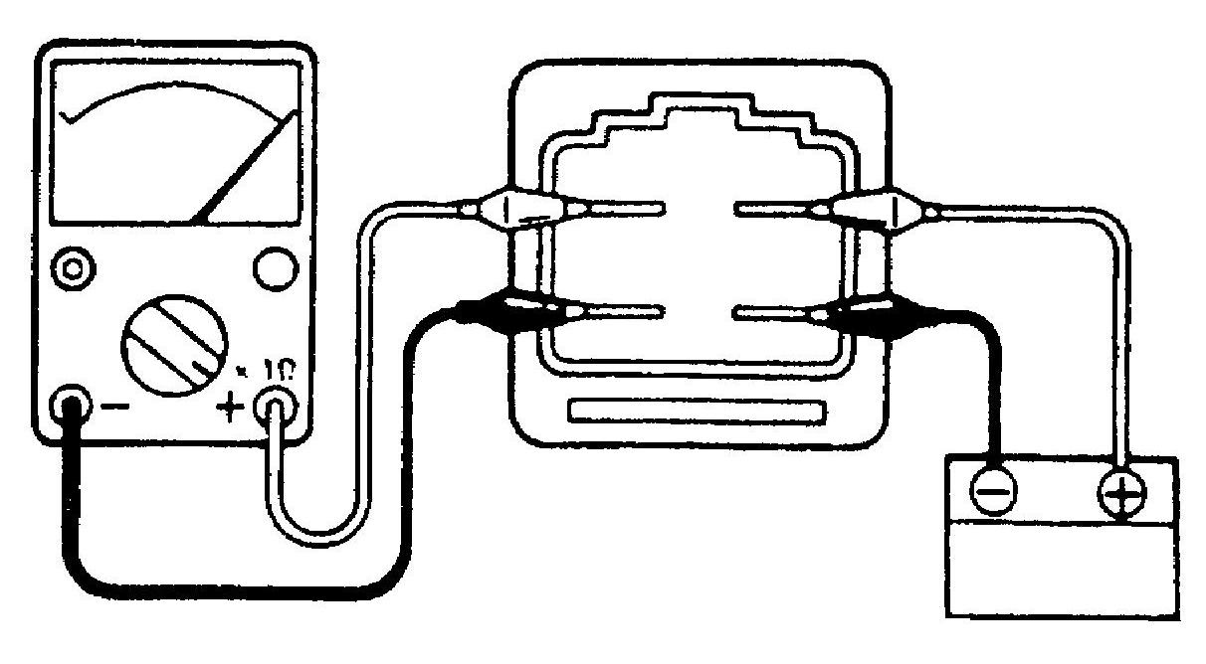 | Replace the starting circuit cut-off relay

- Main switch  CHECK SWITCHES |  | NO CONTINUITY  Replace the main switch
7. Engine stop switch |  | NO CONTINUITY  Replace the handlebar switch
8 Front /rear brake switch  CHECKING SWITCHES |  | NO CONTINUITY  Replace the brake switch
9. Starter switch  CHECKING SWITCHES |  | NO CONTINUITY  Replace the handlebar switch
10. Wiring connection  Check the connections of the entire starting system.  Refer to “CIRCUIT DIAGRAM |  | POOR CONNECTION  Correct

8.6 COOLING SYSTEM

IF THE FAN MOTOR FAILS TO TURN
Procedure
Check:
1. Fuse (Main, Fan)
2. Battery 4. Fan motor (inspection)
3. Main switch 5. Thermo switch
6. Wiring connection (entire cooling system)

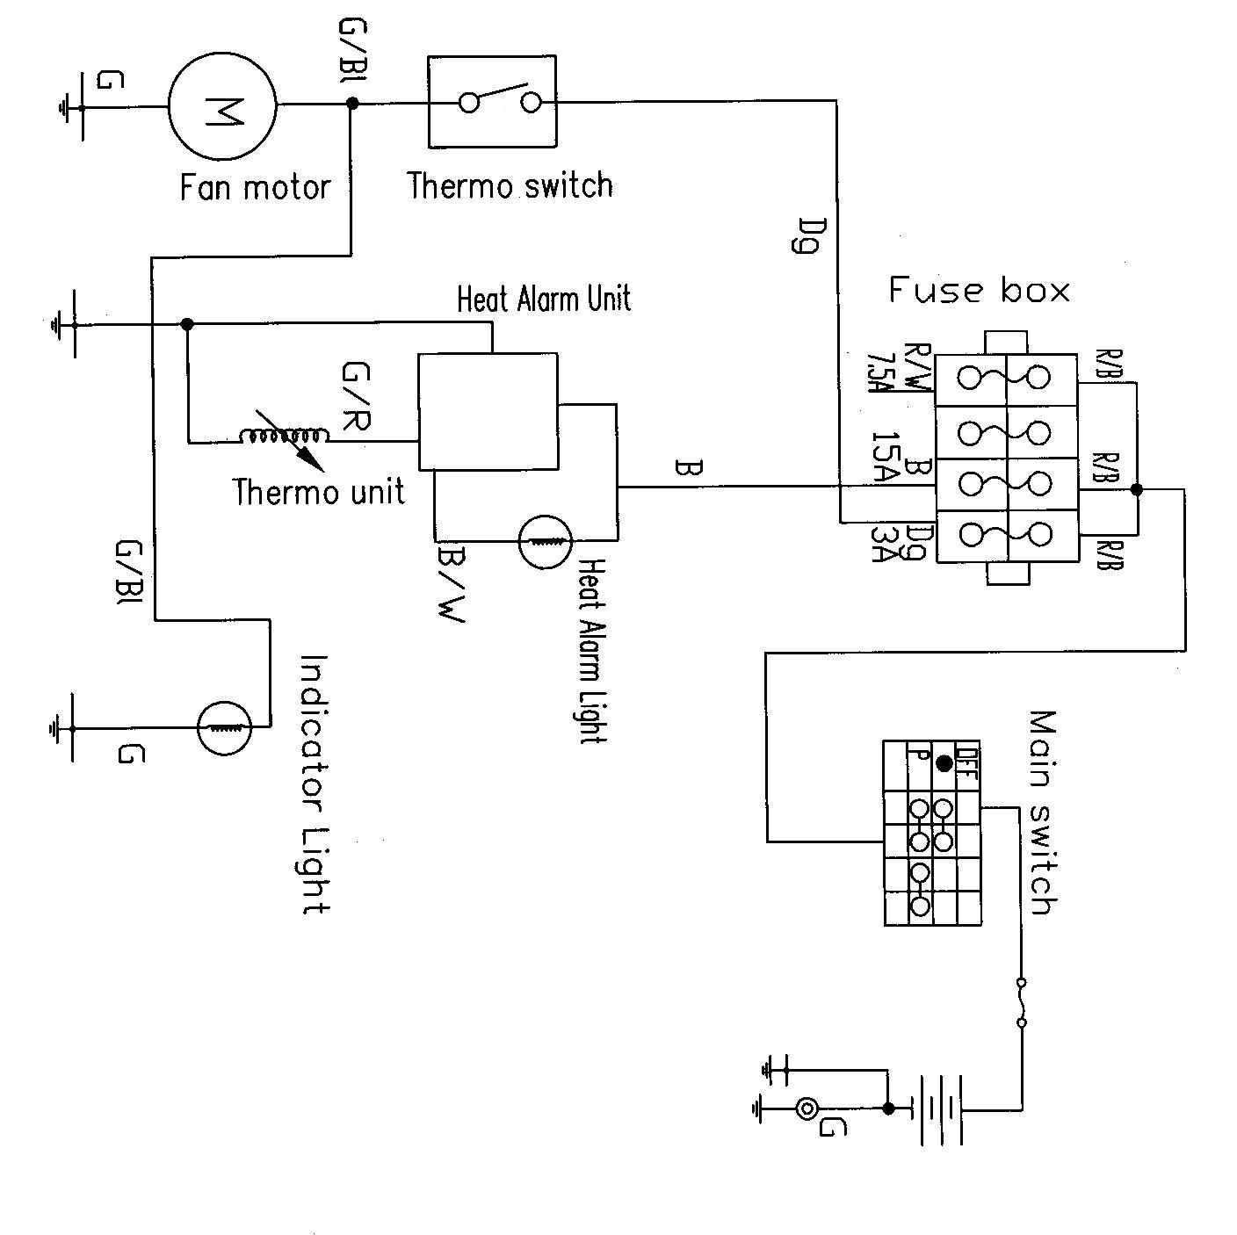

1. fuse  CHECK SWITCHES |  | NO CONTINUITY  Replace the fuse
2. Battery  Check the battery condition.  Refer to "BATTERY INSPECTION" section |  | INCORRECT  Clean battery terminals  Recharge or replace the battery
3 Main switch  CHECK SWITCHES |  | NO CONTINUITY  Replace the main switch
- Fan motor(inspection 1)  Connect the battery to the fan motor.  Battery (+) lead→Green/Blue terminal ①  Battery (-) lead→Green ground ②  Check the fan motor operation |  | DOES NOT MOVE
 |  | Replace fan motor
- Fan motor (inspection 2)  Turn the main switch to off.  Remove the thermo switch lead from thermo switch.  Connect jumper lead to thermo switch leads.  Turn the main switch to on |  | DOES NOT MOVE  The wiring circuit from battery to fan motor is faulty. Repair
6. Thermo switch  Remove the thermo switch from the radiator.  Connect the pocket tester (ΩX1) to the thermo switch①.  Immerse the thermo switch in the water ②  Check the thermo switch for continuity.  NOTE:  Measure temperatures while heating the coolant with the temperature gauge |  | 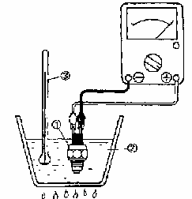
WARNING  Handle the thermo switch with special care.  Never subject it to strong shocks or allow it to be dropped. Should it be dropped, it must be replaced.  Do not touch the thermo switch to the bottom of the heated vessel.  88±3℃Thermo switch “ON”  80 ℃Thermo switch “OFF” |  | OUT OF SPECIFICATION  Replace the thermo switch
Wring connection  Check the connection of the entire cooling system.  Refer to “CIRCUIT DIAGRAM” |  | UPPER CONNECTION  Correct

IF THE Heat Alarm Unit WORKING
When the main switch is turned on, the temperature of the engine begins to go up. As it comes to 88±3℃ the thermostat is connected and the fan starts to work, cooling the coolant, if the thermostat or the fan, fails to work; the coolant temperature will keep rising. The heat alarm unit operates the moment the temperature reaches 115±5℃ with the buzzer sounding and the signal flashing. Stop the engine now to have the circuit fixed.
Procedure
Check:
1 .Fuse(Main, Fan) 4. Thermo unit
2. Battery 5. Voltage
3.Main switch 6. Wiring connection (entire cooling system)

1. fuse  CHECKING SWITCHES |  |  | NO CONTINUITY  Replace the fuse
2. Battery  Check the battery condition.  Refer to "BATTERY INSPECTION" |  |  | INCORRECT  Clean battery terminals  Recharge or replace the battery
3.Main switch  CHECKING SWITCHES |  |  | NO CONTINUITY  Replace the main switch
4.Thermo unit  Drain the coolant and remove the thermo unit from the cylinder head.  Immerse the thermo unit ②in the coolant③ .  ①Thermometer.  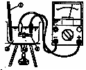 |  |  | Handle the thermo unit with special care. Never subject it to strong shocks or allow it to be dropped.  Should it be dropped, it must be replaced.  Do not touch the thermo unit to the bottom of the heated vessel.
Coolant temperature | Resistance |  | OUT OF SPECIFICATION  Replace the thermo unit
80℃ | 47.5~56.8Ω |  | OUT OF SPECIFICATION  Replace the thermo unit
100℃ | 26.2~29.3Ω |  | OUT OF SPECIFICATION  Replace the thermo unit
MEETS SPECIFICATION

- Voltage  Connect the pocket tester (DC20V) to the  Temperature gauge couple.  Tester (+) lead→Green/Blue terminal  Tester (-) lead→Green ground  Turn the main switch to on.  Check for voltage (12V) on the temperature gauge lead. |  |  | OUT OF SPECIFICATION  The wiring circuit from main switch to temperature gauge is faulty. Repair.
- Wiring connection check the connections of the entire cooling system.  Refer to “CIRCUIT DIAGRAM” |  |  | POOR CONNECTION  CORRECT
Replace the temperature gauge

8.7 LIGHTING SYSTEM

FOR USA MODEL

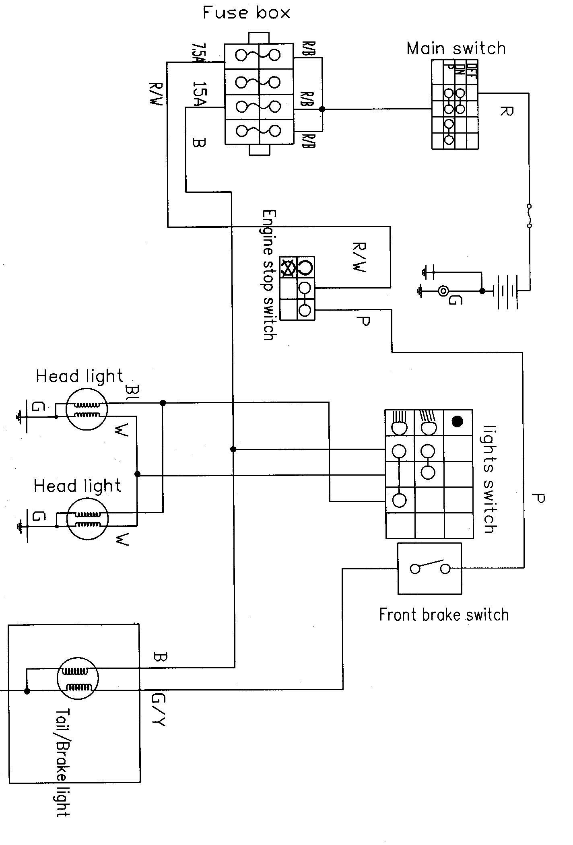

FOR EUROPE MODEL
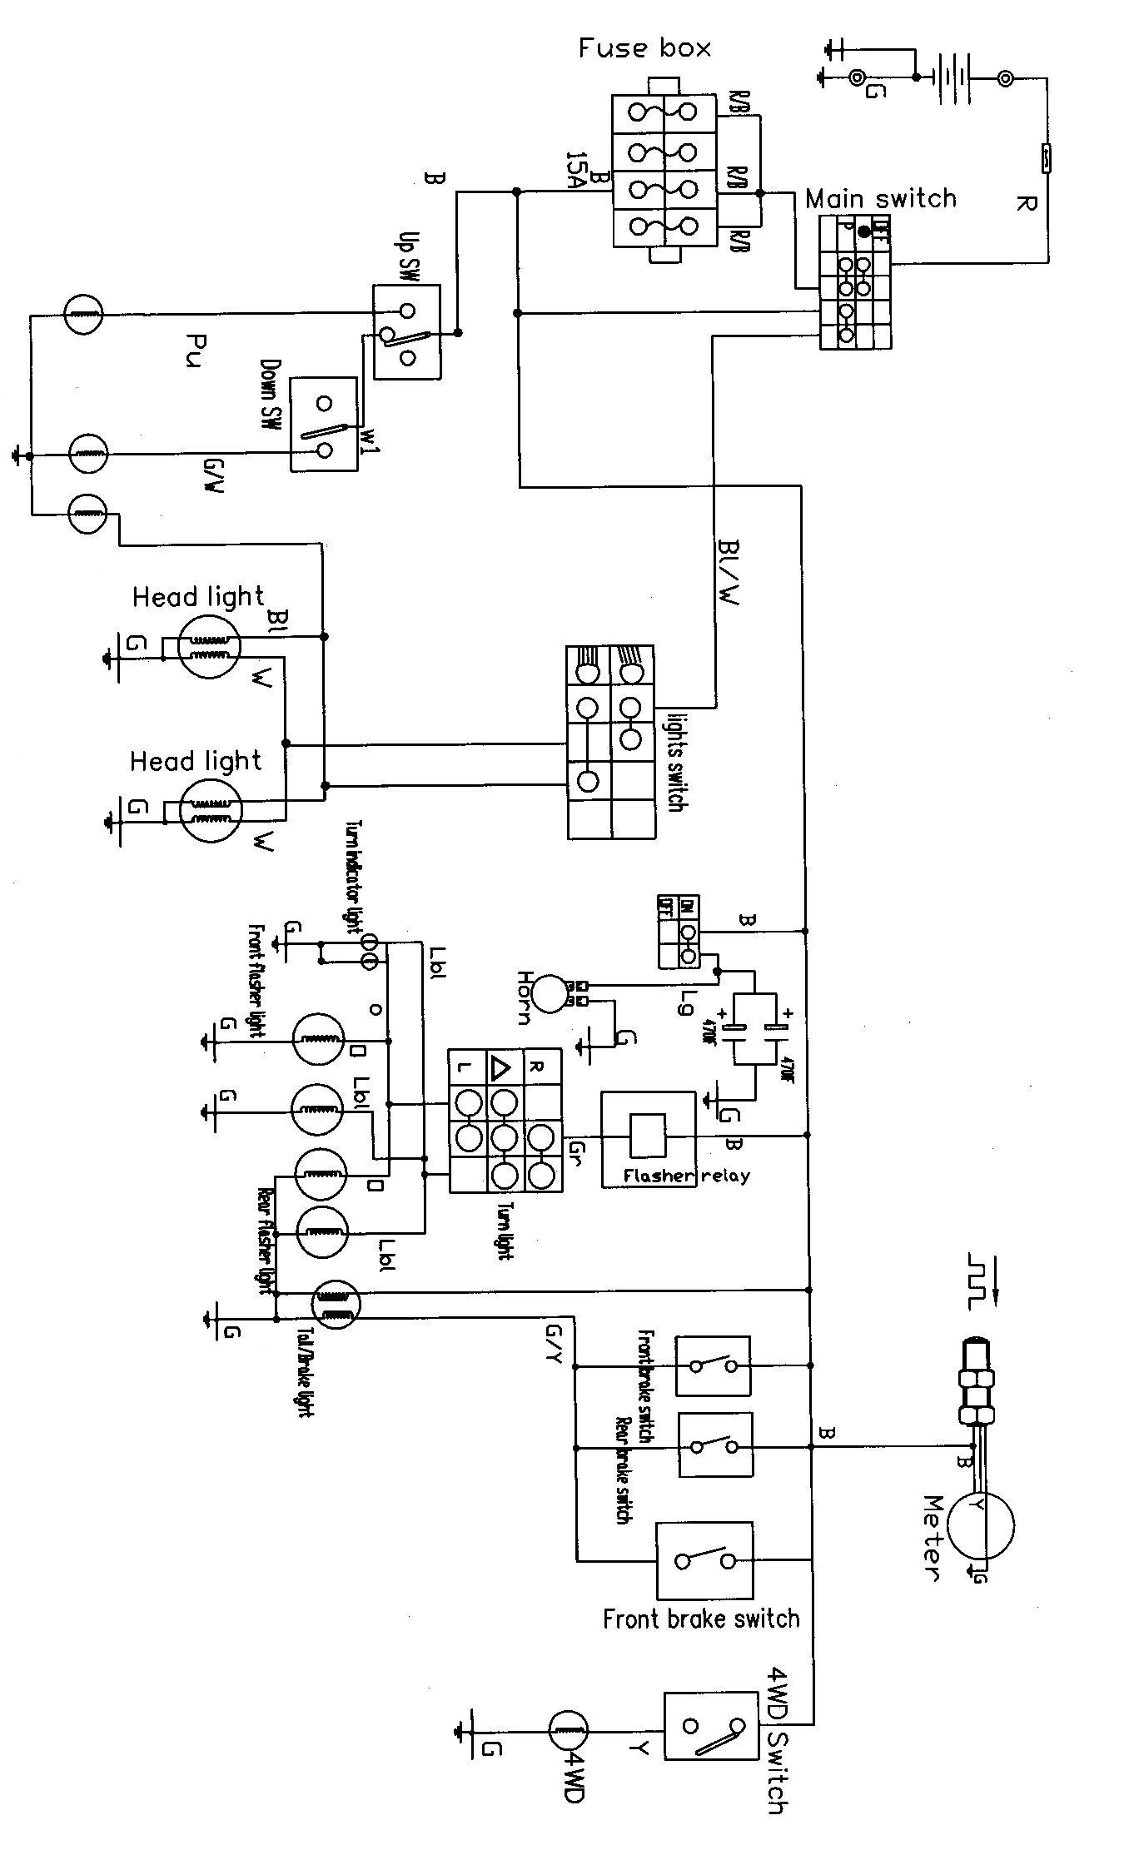

TROUBLESHOOTING
Procedure
Check:
- Fuse (Main) 4.Lights switch
- Battery 5.Dimmer switch
- Main switch 6. Wiring connection (entire lighting system)

1.fuse  refer to “CHECKING SWITCHES” section |  | NO CONTINUITY  Replace the fuse
2. Battery  Check the battery condition.  Refer to “BATTERY INSPECTION” section in CHAPTER 3 |  | INCORRECT  Clean battery terminals  Recharge or replace the battery
3. Main switch  CHECK SWITCHES |  | NO CONTINUITY  Replace the main switch
4. Light switch  CHECK SWITCHES |  | NO CONTINUITY  Replace the right handlebar switch
5. Dimmer sw  CHECK SWITCHES |  | NO CONTINUITY  Replace the left handlebar switch
- Wiring connection  Check the connection of the entire lighting system |  | POOR CONNECTIONS  correct
- check the condition of each of the lighting system’s circuits
Refer to “LIGHTING SYSTEM CHECK”

LIGHT SYSTEM CHECK
1. If the headlight and the high beam indicator light fail to come on
1.Blub and bulb socket  CHECK SWITCHES |  | NO CONTINUITY  Replace the bulb and/ or bulb socket
2. Voltage  Connect the pocket tester (DC20V) to the headlight and high beam indicator light couplers.  A When the dimmer switch is on low beam.  B When dimmer switch is on high beam  Headlight::  Tester (+) lead →White ①or Blue ②lead  Tester negative (-) lead →Green ③lead  Turn the main switch to on.  Turn the light switch to on position.  Turn the dimmer switch to low beam or high beam.  Check for voltage (12V) on the lead at bulb socket connectors  This circuit is not faulty |  | OUT OF SPECIFICATION  The wiring circuit from the main switch to  bulb socket connector is faulty. Repair

- the taillight fails to come on

- Bulb and bulb socket  CHECK SWITCHES |  | NO CONTINUITY  Replace the bulb and /or bulb socket
CONTINUITY

- Voltage  Connect the pocket tester (DC20V) to the bulb  socket connector.  Tester (+) lead→  Black terminal ①  Tester (-) lead→  Green terminal ②  Turn the main switch to on.  Turn the lights switch to on pilot position.  Check the voltage (12V) on the bulb socket connector |  | OUT OF SPECIFICATION  The wiring circuit from main switch to  bulb connector of faulty. Repair
This circuit is not faulty

8.8 REVERSE LIMIT SYSTEM
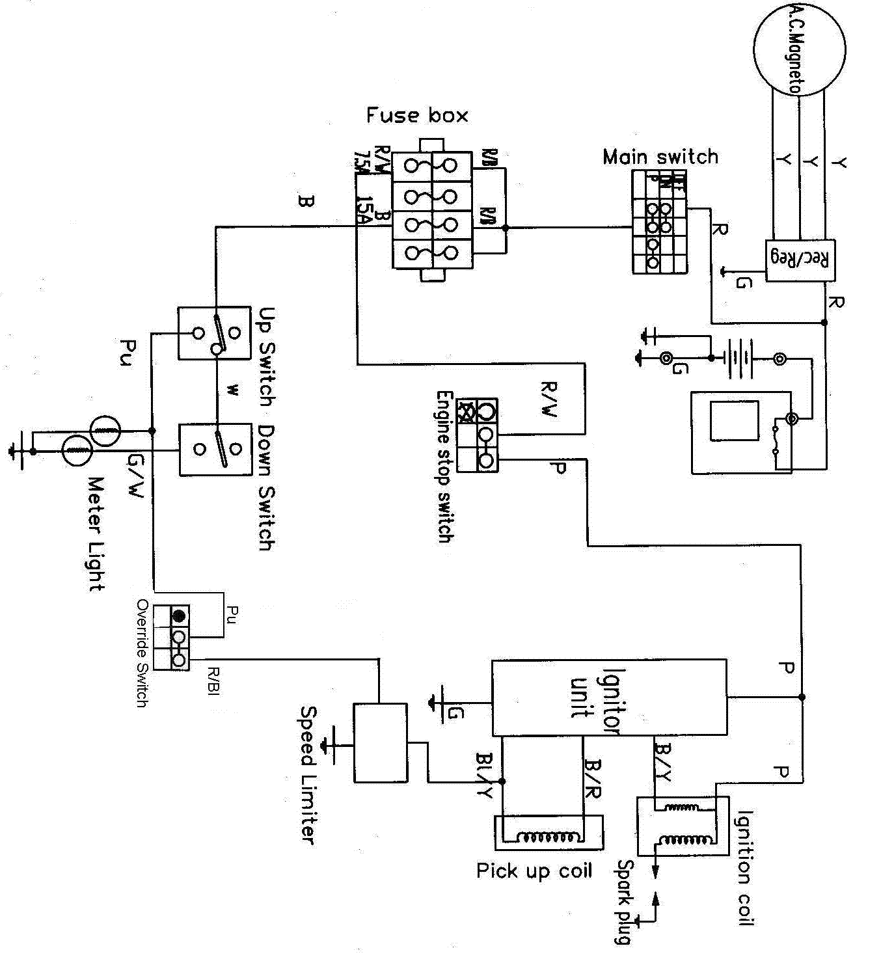

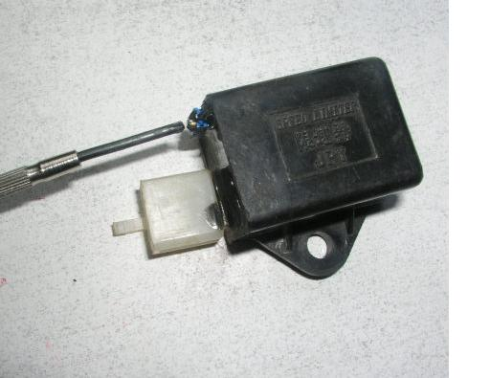
The limit set for the speed limiter by the manufacturer is 13~15 km/h, which can be reset in accordance with the user’s practice. Turning the adjusting bolt clockwise is to increase the speed, while counterclockwise decrease it.

NOTE. This limit can be released by the override switch.

8.9 GEAR POSITION INDICATOR SWITCH TEST
Switch table

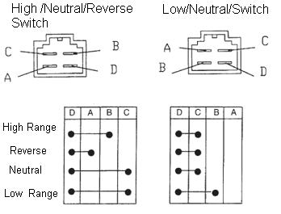

Switch schematic

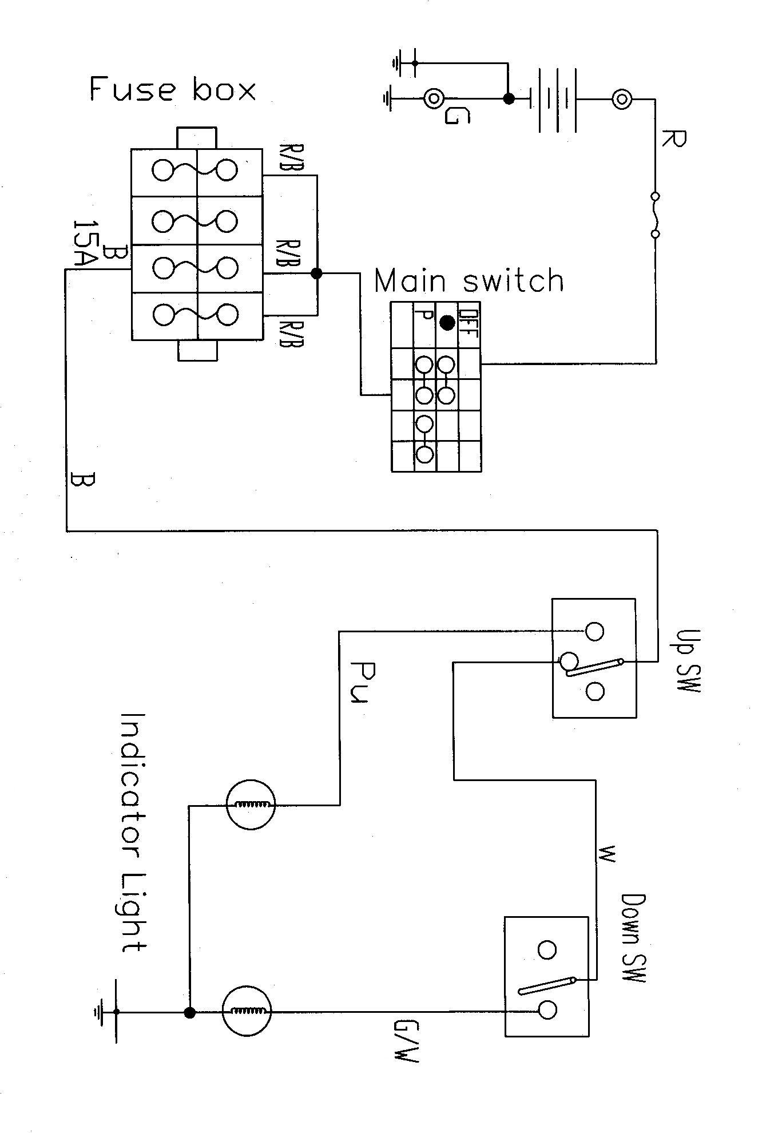

8.10 SPEEDMETER SYSTEM

OPERATION OF SPPED SENSOR
Speed Sensor is on the rear axle
Operation Instructions of Electric Dial Meter and Speed Sensor/ Operation Instructions of LCD Meter and Speed Sensor

- Hall Sensor is a new type sensor used to measure speed, angle, revolution and length, etc by means of voltage pulse signals converted from sensing gear ratio of black metal gear or gear rack.
- Main Technical Parameter for sensor：
Item | Code | Vol value | Unit
Operating voltage | Vcc | 5-20 | V
Operating current | Icc | ≤15 | mA
Low voltage output | Vol | ≤ 0.4 | V
Hight voltage output | Voh | ≥ (Vcc-1) | V
Operating distance | D | 1mm ≤ D ≤ 2.5mm | mm
- The following is the graphic illustration for sensor installation, Wire 1 (red) is positive and wire 2 (black) negative, Wire 3 (yellow) works as the one to output signals.

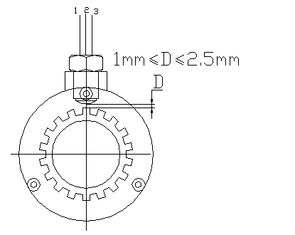

Note: Always screw in the sensor by hand when installation or adjustment.
1, Align one tooth of the splines to the centre of the hole of the sensor by turning the rear axle.
2. Screw the senor in (CW) by hand slightly until resistance is felt.
3. Turn the sensor CCW by 1 to 2 turn(s).
4. Tighten the jam nut.

Speed Sensor on the Transmission Out Put Shaft.
Operation Instructions of LCD Meter and Speed Sensor

Main Technical Parameter：
Item | Code | Vol value | Unit
Operating voltage | Vcc | 5-20 | V
Operating current | Icc | ≤15 | mA
Operating distance | D | 1mm≤D≤8mm | mm
The following is the graphic illustration for sensor installation。
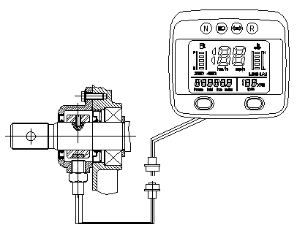
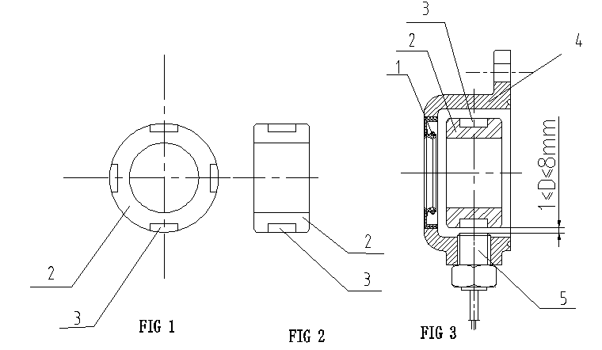
1. OIL SEAL | 4. THE COVER
2. DOWEL PIN | 5. THE HALL SENSOR
3. MAGNET

METER

Dial Meter

Item | Vol value | Unit
Operating voltage | 10V~18V | V
Operating current | ≤ 500mA | A
Operating Environmental temperature | -10℃~65℃ | ℃
Battery warning voltage | ≤11.5V | V
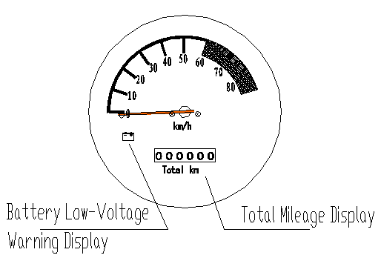
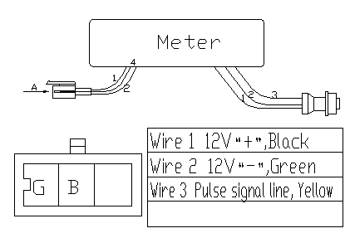

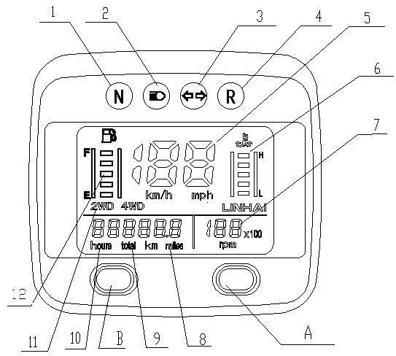
LCD Meter

1. Neutral indicator light | 7. Engine rpm meter
2. High beam indicator light | 8、9. The odometer
3. Turn indicator light | 10.Engine working hour counter
4. Reverse indicator light | 11. 2WD/4WD indicator*
5. Speedometer | A: km/ mile selector
6. Coolant temperature meter* | B: hour / distance selector
 | 12. Fuel gauge Indicator

8.11 MAIN SWITCH AND HANDLE SWITCH

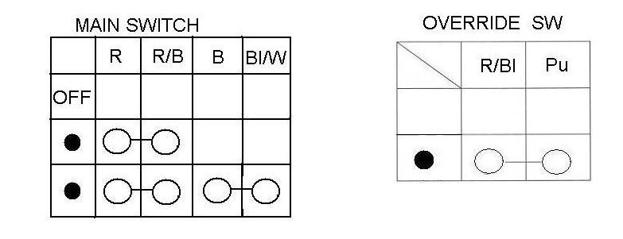

HANDLE SWITCH SCHEMATIC FOR USA MODEL

2004 model
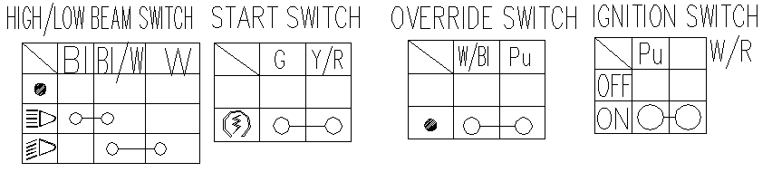

2005 model
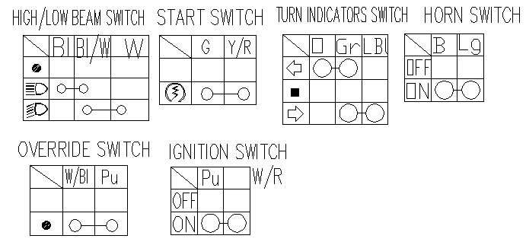

HANDLE SWITCH SCHEMATIC FOR EUROPE MODEL
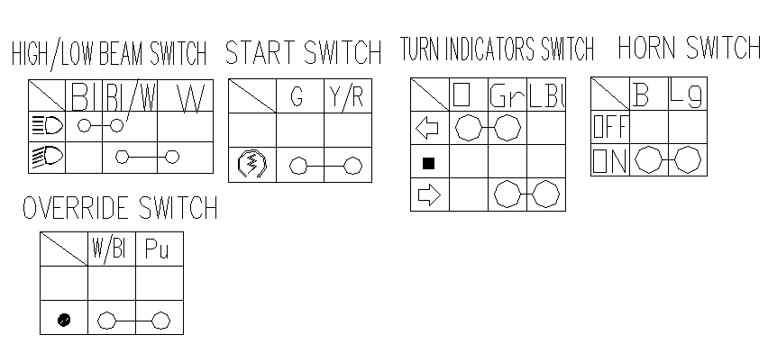

400ATV-2 / 400ATV-2B HANDLE SWITCH SCHEMATIC FOR USA MODEL

400ATV-2 / 400ATV-2B HANDLE SWITCH SCHEMATIC FOR EUROPE MODEL

8.12 FUEL GAUGE/ FUEL LEVEL SENSOR

Removal  Turn the ignition switch to“OFF”.  Remove the fuel tank cover.  Remove the three bolts, retaining plate and fuel level sensor from the fuel tank.  Installation  Install a new seal rubber onto the fuel level sensor.  Install the retainer plate onto the sensor by aligning the tab with the grove.  Install the sensor into the fuel tank while aligning the grove in the plate with the boss on the fuel tank.  Install and tighten the bolts securely.  Install the removed parts in the reverse order of removal.  Fuel Gauge / Fuel level Sensor Inspection  Move the float to the bottom (RESERVE) position, turn the ignition switch to“ON”and check the fuel gauge.  Segment“RES”should blink.  With the fuel level sensor float at the top (FULL) position, turn the ignition switch to “ON” and check the fuel gauge. All segments up to segment “F”should come on.  If the fuel gauge does not function properly, check the fuel level sensor  If the fuel level sensor is OK, replace the LCD Meter.  Fuel level Sensor Inspection  Disconnect the fuel level sensor 2p Green connector and connect the ohmmeter to the sensor side connector terminals.  Measure the fuel level sensor resistance with the float at the top (FULL)  And bottom (RESERVE) positions. | 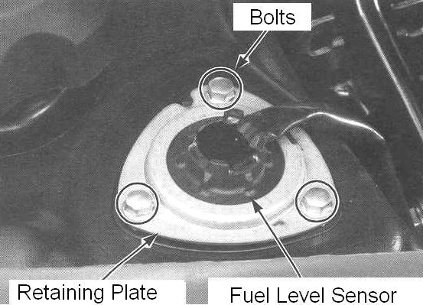  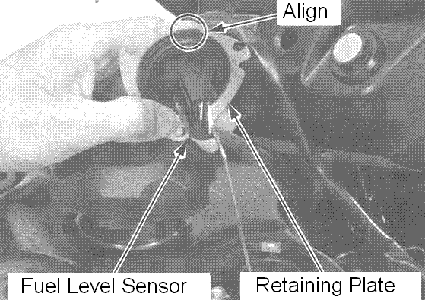  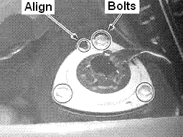  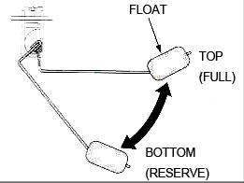  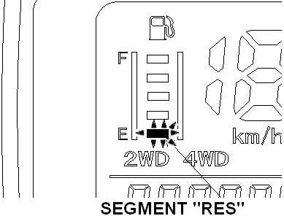  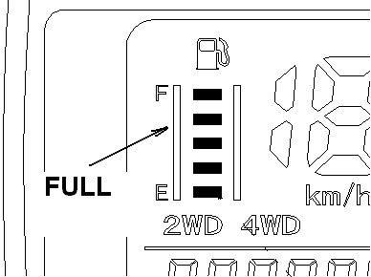
  FLOAT POSITION | RESISTANCE(20℃/ 68°)
  TOP(FULL) | 4-10Ω
  BOTTOM(RESERVE) | 100-110Ω

8.13 THE OPERATION PRINCIPLE OF THE ELECTRIC 4WD SHIFT
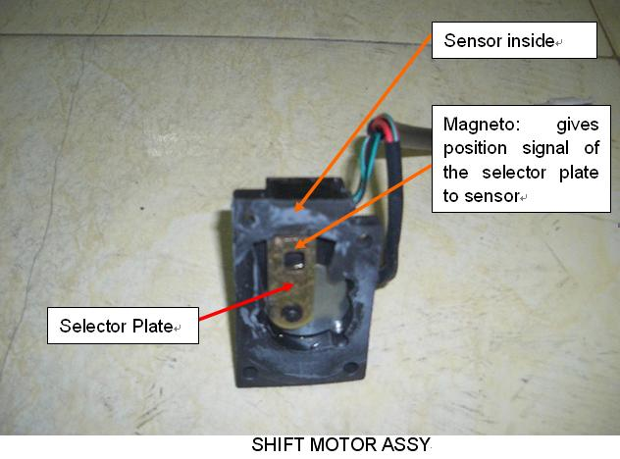
(Fig 1)

1, The rider shifts 2WD to 4WD by the Switch on handlebar.
2. The Switch gives signal to Controller.
3, The controller gives power to the Shift Motor.
4, If the Splined Dog (Fig 2) is in right position, 4WD will engage immediately. This information will be given to the Sensor by the Magneto on the Selector Plate, and then to the Controller. Controller lights the 4WD indicator.
5. If the Splined Dog is not in right position, 4WD won’t engage, this information will be given to the Sensor by the Magneto on the Selector Plate, and then to the Controller. The controller will try to drive the Shift Motor several times in 1 min.
During this time, the 4WD indicator is not on, this requires the rider to back or move (ride) the ATV a little to allow the Dog change position for engagement. ( See owner’s manual or decal).
If the rider doesn’t do as the owner’s manual, after 1 min, the buzzer comes on and 4WD indicator blinks, remind the rider to re-shift.

Shift from 4WD to 2WD is same as above.

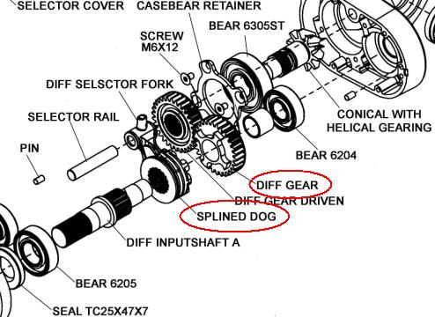
(Fig 2)

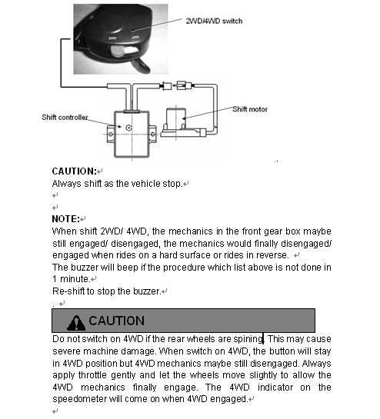

（Fig 3）Page from owner’s manual

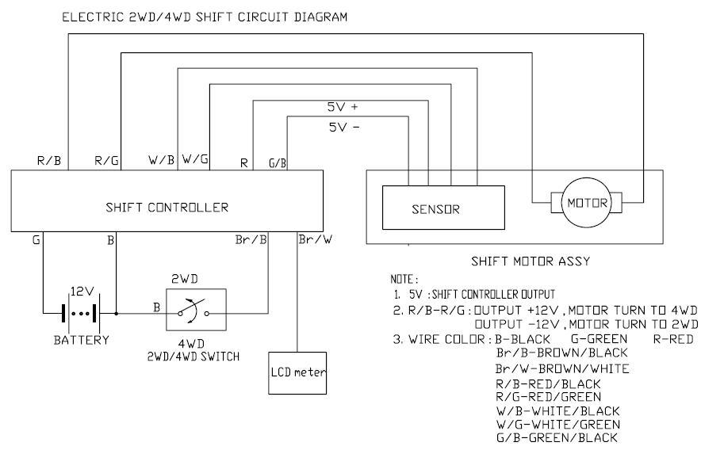
（Fig 4）

8.14 WIRING DIAGR




